Seamless Horizon Lighting for Maya
Kiel Figgins – www.3dfiggins.com

*UPDATED (3/8/05)* - Multiple people have written to me about this tutorial and mentioned various other ways of achieving it. Special thanks to Chris Adams for being the first to really trim it down. Here’s the revised steps:

1. Create the Ground Plane.
2. Create a new “Use Background” shader.
3. Apply the shader to the Ground Plane.
4. Render.
5. To adjust the background color of a camera, in the camera plane, select View>Select Camera. Then in the Attribute Editor, choose Environment, and use the color swatch.

Original Tutorial

Here is how I do my lighting in Maya to have crisp ground shadows with no horizon line and without using Raytracing.

First off, Depth Map Shadows are a calculation of what the shadow should be like, it’s essentially a black map projected from the light. You can adjust this setting and various others in the Attribute Editor of the selected light. With this in mind, realize this map is based off the default size of the Maya grid.

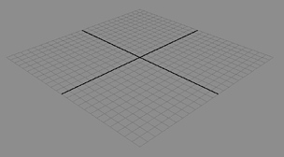
- So first off, if at all possible, scale your scene down to fit within the grid.
- This is a general scene with no lights, rendered with Production Quality.
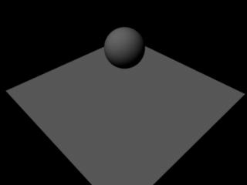
- It’s just a plane and a Ball. Now create 3 Directional lights, Default settings. Arrange these lights to adjust for the Key, Fill, Back Light lighting scheme (Key,1, being main light, Fill,3, being general illumination, and Back Light,2, set roughly opposite facing the Key Light)
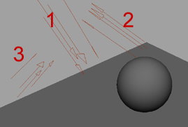

- Re-render and you’ll end up with this result, after a few adjustments in the Attribute Editor (below).
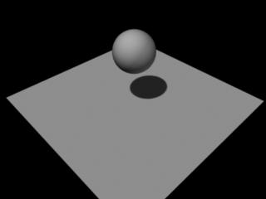
- Now Adjust the Key Light to roughly these settings. Intensity = 1.5, Shadow Color a bit above Black, Use Depth Map Shadows Checked, Dmap Resolution to 1024, Dmap Filter Size to 3. Note: It’s best, I find at least, not to have jet black shadows, and of course, adjust these settings to be more appropriate to your own scene. Set the Intensity on the Fill Light to about .4 and on the Back Light to about .7.
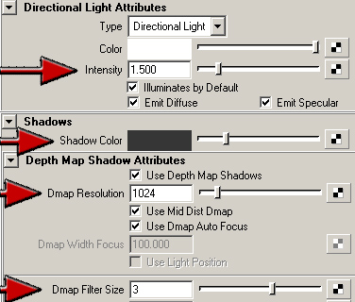
- Next Create 2 new materials, a Blinn and a Lambert. Apply the Blinn to the Ball and the Lambert to the plane. I prefer to have my characters have the only Blinn highlights; it draws the eye more and separates it more from the background. Also, applying a different material to the plane allows for adjustments to the ground color separately.
- Resulting in this.
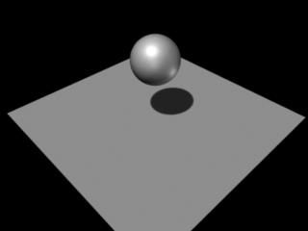
- Now select your camera that you’re rendering from. An easy way to do this is while looking through it, View>Select Camera. Open the Attribute Editor (ctrl-a).
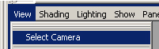
- While your camera’s attribute editor is open, unfold the Environment tab. Double click the color swatch for Background Color. The Color Chooser comes up. With your Render Window still open, click with the Eye Drop Tool on to the ground plane in the Render window. Re-render.
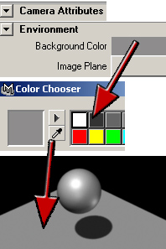
- You should end up with this.
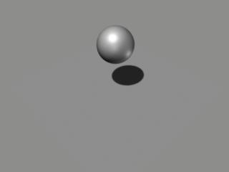

And you’re done. Adjust any settings to get the desired look. I’ve to adjust it almost every time for each different scene, but after the first time or so, it’s very quick to set up and usually very fast to render.

Some cases to watch out for.

- Camera going below plane.
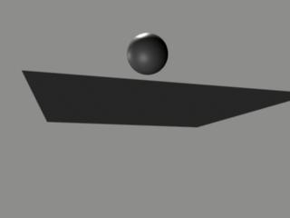
- Object going past plane, the shadow being cropped sticks out badly during an animation or scene.
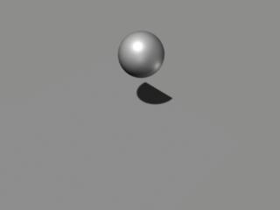
- Ground plane too big, Dmap filter to high, ect… fuzzy shadow that this tutorial was supposed to get ride of ( I think this ground plane is 1000 or so).
